**library-management-system**

You are going to build a project based on Library Management System. It keeps track of all information about books in the library, their cost, status and total number of books available in the library.

Create a database named library and following TABLES in the database:   
  
1. Branch

create database library;

use library;

-- branch table

CREATE TABLE Branch (

Branch_no CHAR(5) PRIMARY KEY,

Manager_Id INT NOT NULL,

Branch_address VARCHAR(30),

Contact_no BIGINT

);  
2. Employee

CREATE TABLE employee (

Emp_Id INT PRIMARY KEY,

Emp_name VARCHAR(20),

Position VARCHAR(20),

Salary INT NOT NULL,

Branch_no CHAR(5),

FOREIGN KEY (Branch_no)

REFERENCES Branch (Branch_no)

);   
3. Books

CREATE TABLE Books (

ISBN INT PRIMARY KEY,

Book_title VARCHAR(650) NOT NULL,

Category VARCHAR(200),

Rental_Price INT NOT NULL,

Status varchar(3),

Author VARCHAR(250),

Publisher VARCHAR(205)

);  
4. Customer

CREATE TABLE Customer (

Customer_id INT PRIMARY KEY,

Customer_name VARCHAR(20),

Customer_address VARCHAR(30),

Reg_date DATETIME DEFAULT CURRENT_TIMESTAMP

);  
5. IssueStatus

CREATE TABLE IssueStatus (

Issue_Id INT PRIMARY KEY,

Issued_cust INT,

Issue_date DATETIME DEFAULT CURRENT_TIMESTAMP,

Isbn_book INT,

FOREIGN KEY (Issued_cust)

REFERENCES Customer (Customer_id),

FOREIGN KEY (Isbn_book)

REFERENCES Books (ISBN)

);  
6. ReturnStatus

CREATE TABLE ReturnStatus (

Return_Id INT PRIMARY KEY,

Return_cust INT,

Return_book_name VARCHAR(150),

Return_date DATETIME DEFAULT CURRENT_TIMESTAMP,

Isbn_book2 INT,

FOREIGN KEY (Isbn_book2)

REFERENCES Books (ISBN),

FOREIGN KEY (Return_cust)

REFERENCES Customer (Customer_id)

);

Created Some triggers and Views

-- Creating a view to get the no of books in the library ,available books , and books gone out

create view Books_Count AS select(select count(*) from Books) total_no_of_books ,

(select count(*) from Books where Status ='yes') no_of_books_available_now,

(select count(*) from Books where Status ='No') no_of_books_gone_out;

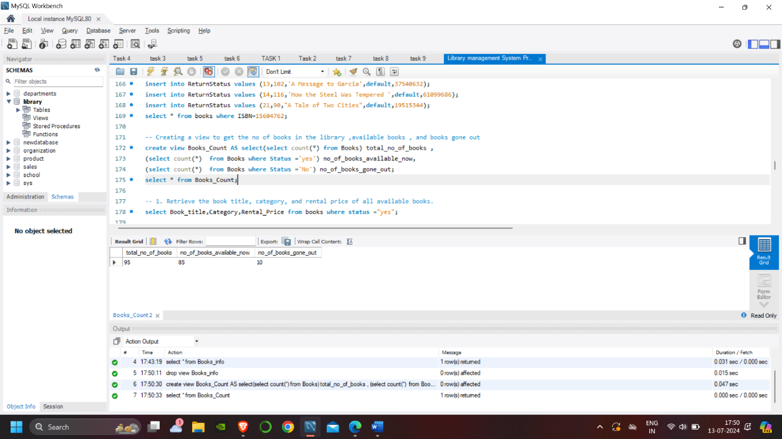

-- creating trriger before inserting the data into issuestatus to not select avoid entering book not available by checking the books table

delimiter $$

create trigger before_issue_book_to_customer before insert on IssueStatus for each row

begin DECLARE book_status varchar(3);

SELECT Status INTO book_status FROM Books WHERE ISBN = NEW.Isbn_book;

IF book_status = "No" THEN

SIGNAL SQLSTATE '45000'

SET MESSAGE_TEXT = 'Cannot issue a book that is not available';

end if;

end$$

delimiter ;

-- creating trigger after insertion for changing update the book status form the book table as not available after that book is issuesed to customer

delimiter $$

create trigger after_issue_book_to_customer after insert on IssueStatus for each row

begin UPDATE Books

SET Status = "no"

WHERE ISBN = NEW.Isbn_book;

end$$

delimiter ;

-- creating after triggers to change the book status from no to yes

delimiter $$

create trigger after_return_book_to_customer after insert on ReturnStatus for each row

begin UPDATE Books

SET Status = "Yes"

WHERE ISBN = NEW.Isbn_book2;

end$$

delimiter ;

-- 1. Retrieve the book title, category, and rental price of all available books.

select Book_title,Category,Rental_Price from books where status ="yes";

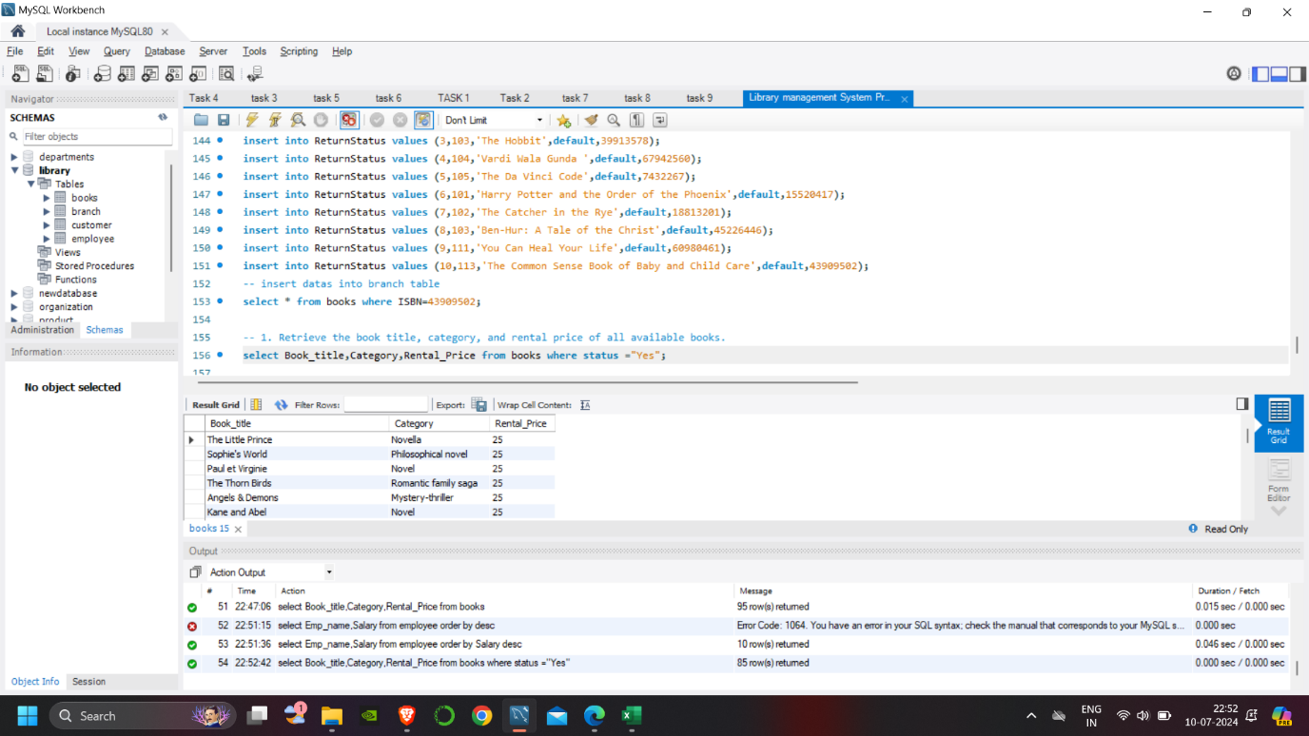

-- 2. List the employee names and their respective salaries in descending order of salary.

select Emp_name,Salary from employee order by Salary desc;

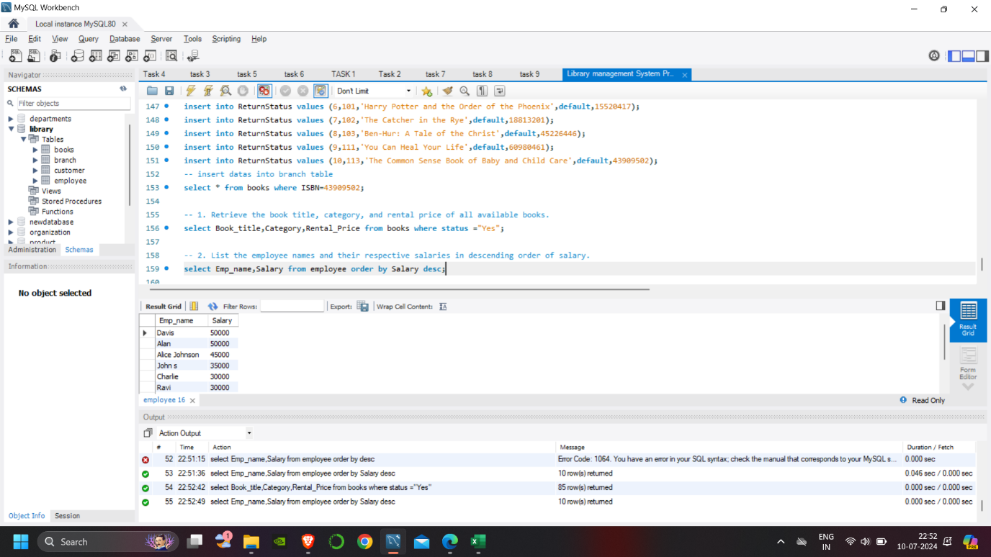

-- 3. Retrieve the book titles and the corresponding customers who have issued those books.

SELECT

B.Book_title, I.Issued_cust, C.Customer_name

FROM

IssueStatus I

LEFT JOIN

Books B ON I.Isbn_book = B.ISBN

LEFT JOIN

Customer C ON I.Issued_cust = C.Customer_id;

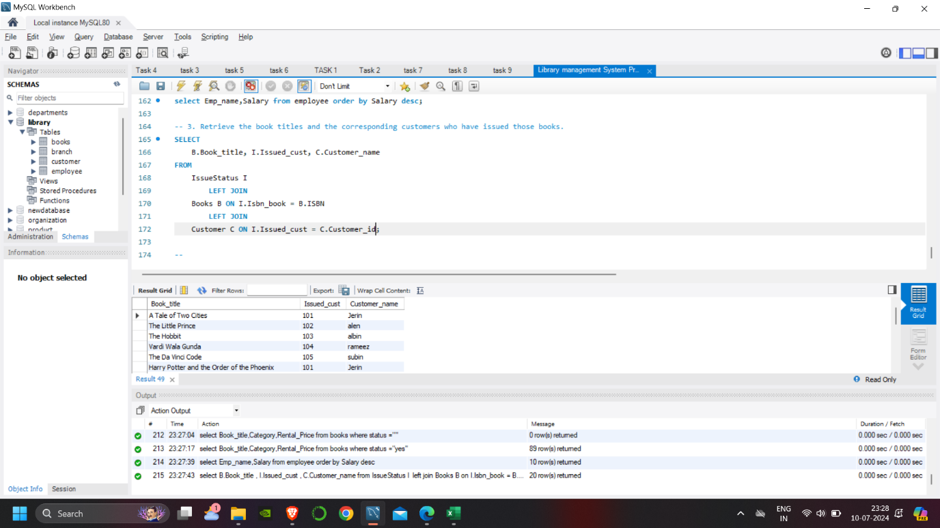

-- 4. Display the total count of books in each category.

SELECT

COUNT(*), category

FROM

books

GROUP BY category;

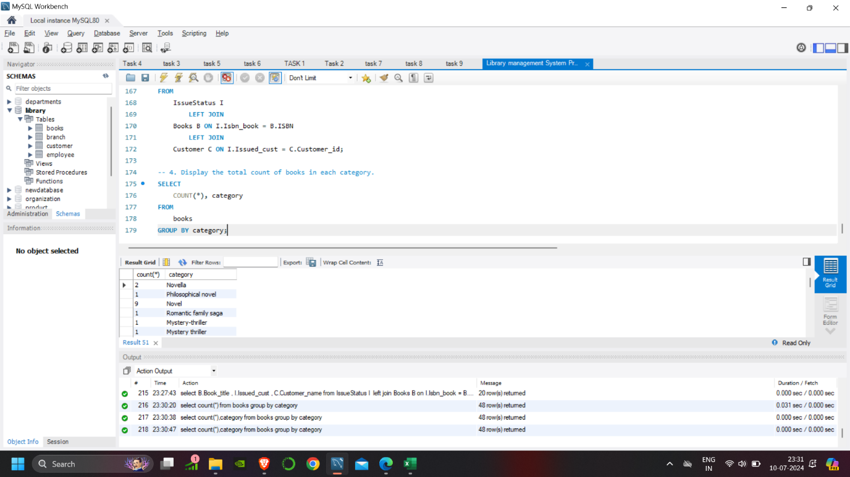

-- 5. Retrieve the employee names and their positions for the employees whose salaries are above Rs.50,000.

SELECT

Emp_name, position

FROM

employee

WHERE

salary > 50000;

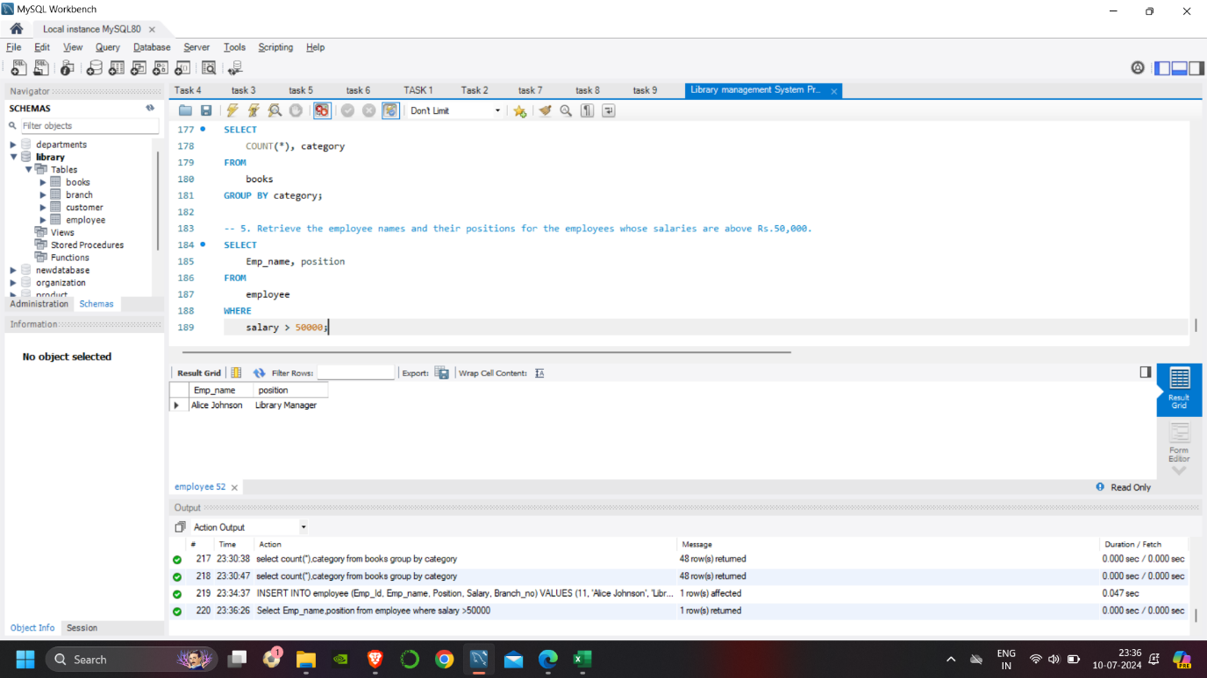

-- 6. List the customer names who registered before 2022-01-01 and have not issued any books yet.

SELECT

customer_name

FROM

customer

WHERE

customer_id NOT IN (SELECT

issued_cust

FROM

IssueStatus)

AND Reg_date < '2022-01-01';

-- another way

SELECT

c.customer_name

FROM

customer c

LEFT JOIN

IssueStatus i ON i.issued_cust = c.customer_id

WHERE

Reg_date < '2022-01-01'

AND i.issued_cust IS NULL;

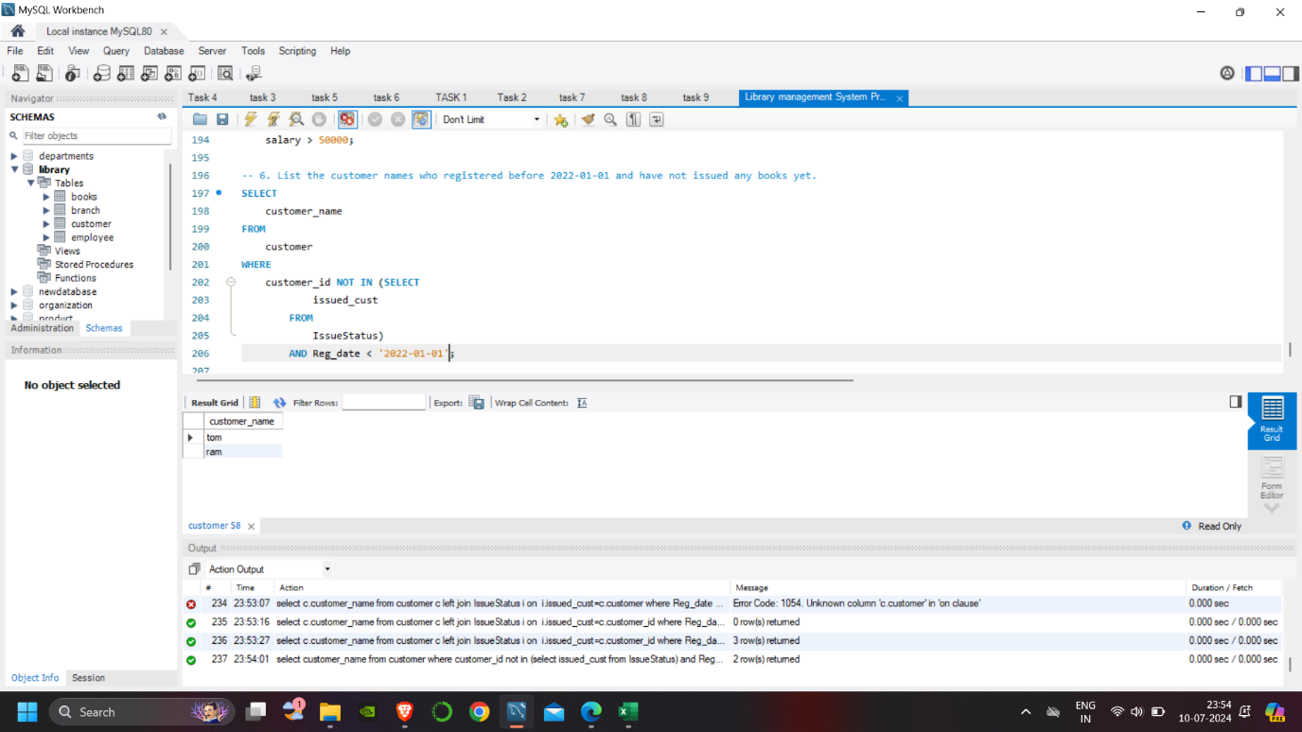

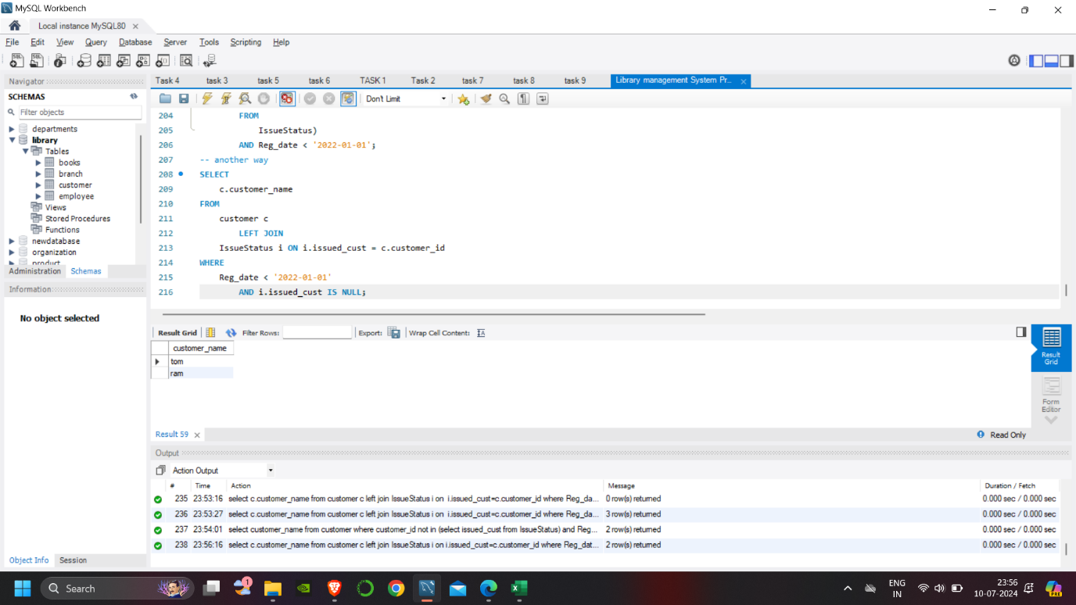-- 7. Display the branch numbers and the total count of employees in each branch.

SELECT

b.Branch_no, COUNT(e.Emp_Id)

FROM

employee e

LEFT JOIN

Branch b ON e.Branch_no = b.Branch_no

GROUP BY Branch_no;

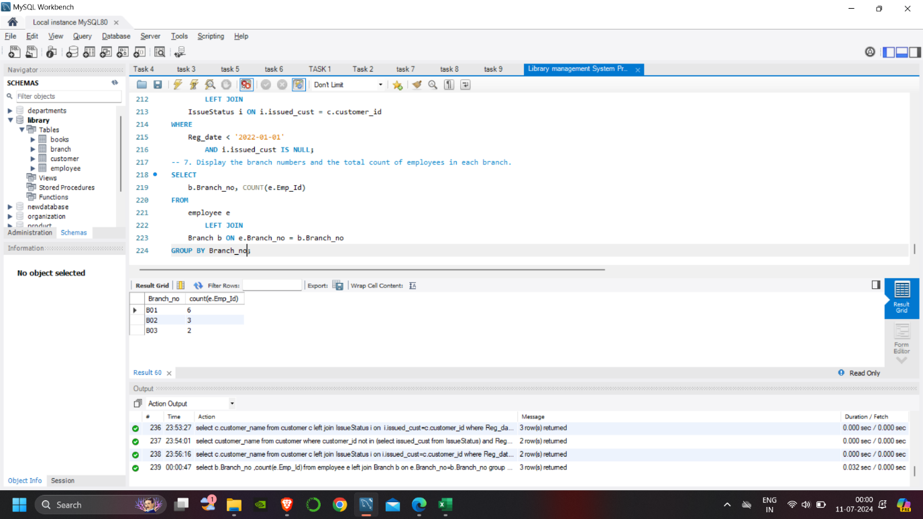

-- 8. Display the names of customers who have issued books in the month of June 2023.

SELECT

c.customer_name

FROM

customer c

LEFT JOIN

IssueStatus i ON i.issued_cust = c.customer_id

WHERE

Issue_date BETWEEN '2023-06-01' AND '2023-06-30';

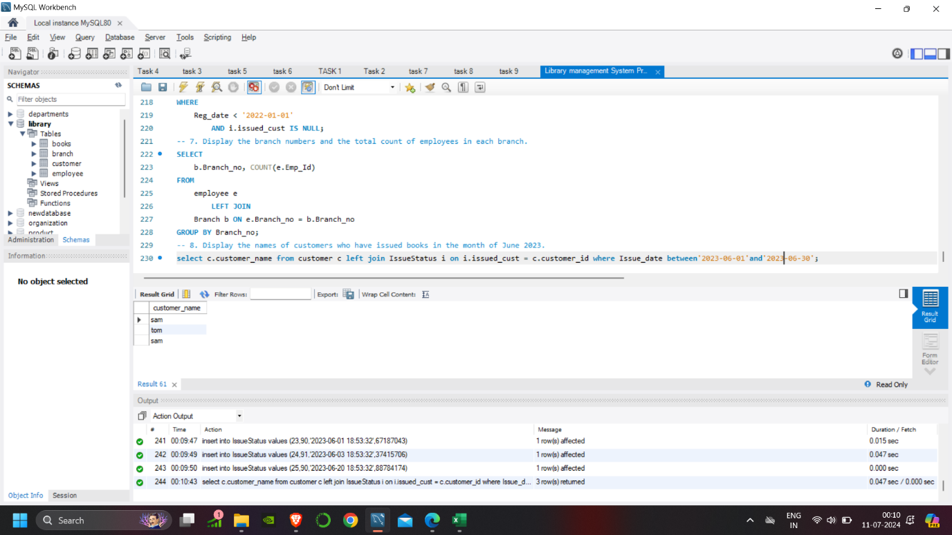

-- 9. Retrieve book_title from book table containing history.

SELECT

book_title

FROM

books

WHERE

book_title LIKE '%history%';

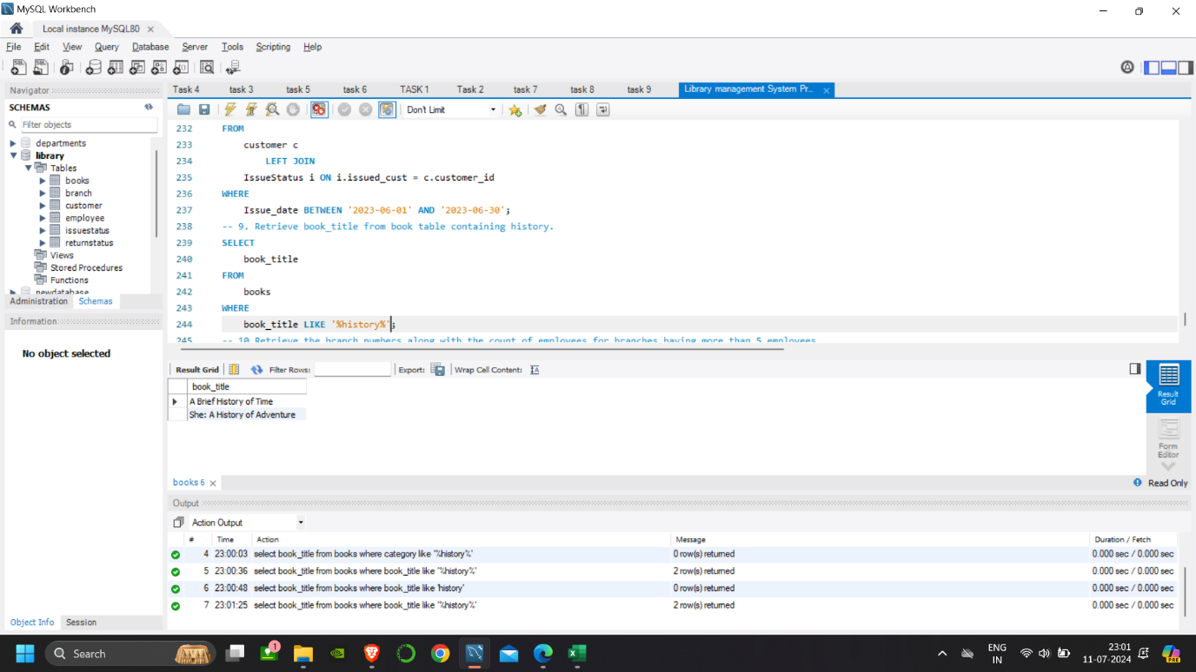

-- 10.Retrieve the branch numbers along with the count of employees for branches having more than 5 employees

SELECT

branch_no, COUNT(Emp_Id) no_of_emp

FROM

employee e

GROUP BY branch_no

HAVING COUNT(Emp_Id) > 5;

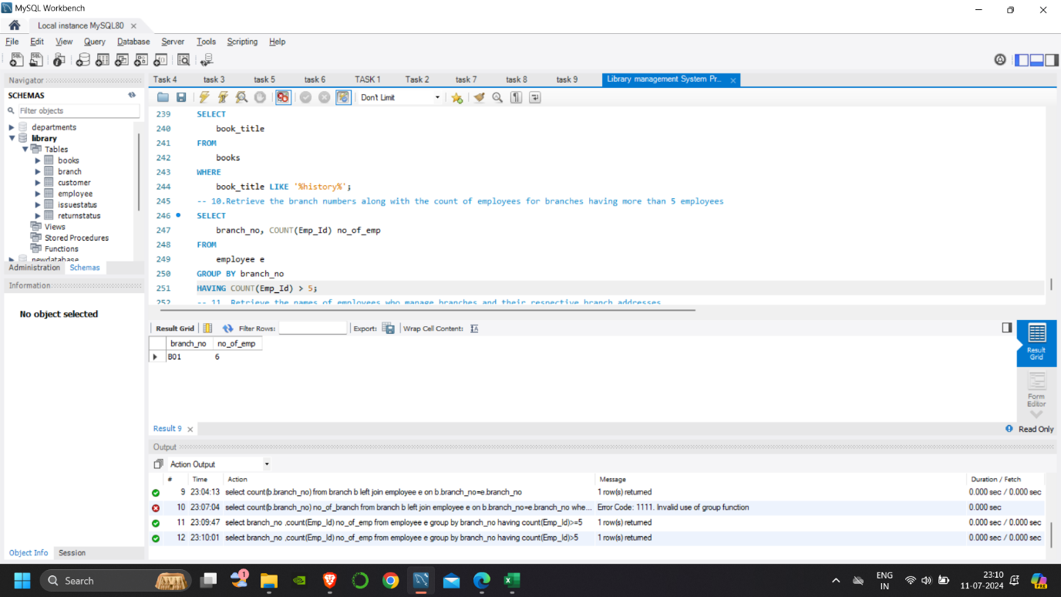

-- 11. Retrieve the names of employees who manage branches and their respective branch addresses.

SELECT

e.Emp_name, b.Branch_address, e.position

FROM

employee e

LEFT JOIN

Branch b ON b.Branch_no = e.Branch_no

WHERE

position LIKE '%manager%';

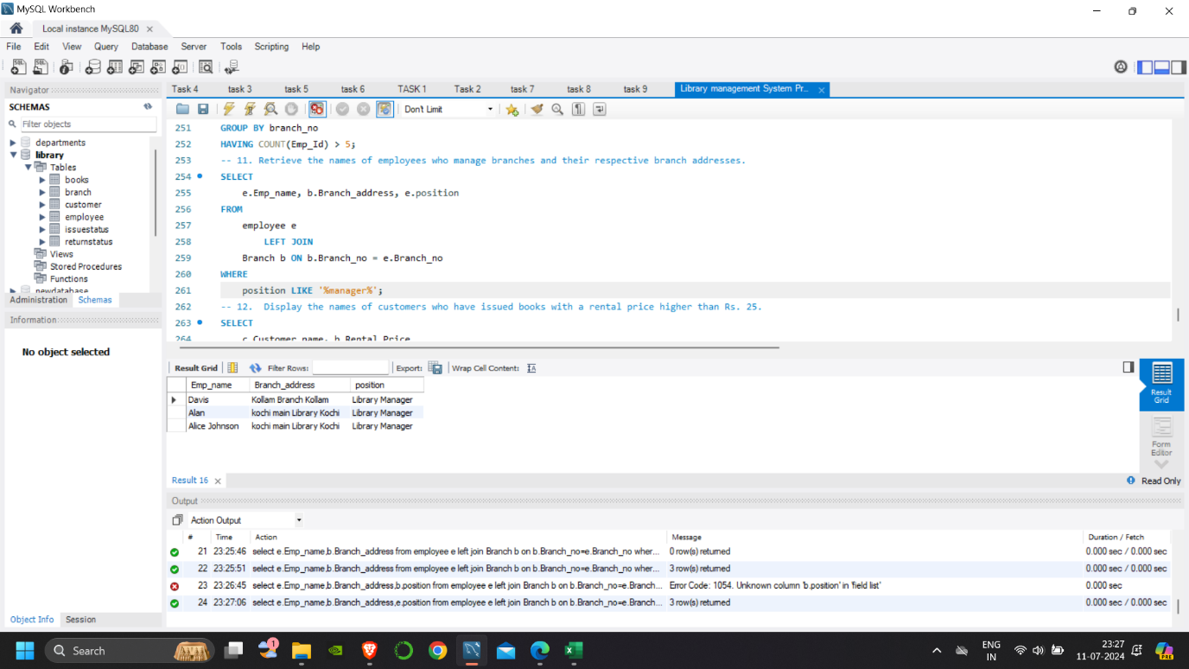

-- 12. Display the names of customers who have issued books with a rental price higher than Rs. 25.

SELECT

c.Customer_name, b.Rental_Price

FROM

IssueStatus i

LEFT JOIN

customer c ON c.Customer_id = i.Issued_cust

LEFT JOIN

books b ON b.ISBN = i.Isbn_book

WHERE

Rental_Price > 25;

